

Add one more page – Ikigai Future Group Ventures (after Brands)

Add another page – News Letter

Add another Page – Careers

Want to be a global Change-Maker? Join our team.

At Ikigai, we believe exceptional performance begins with hiring, celebrating, and nurturing the best talent from diverse backgrounds.

Countries list

India, GCC, Singapore, Malaysia, China

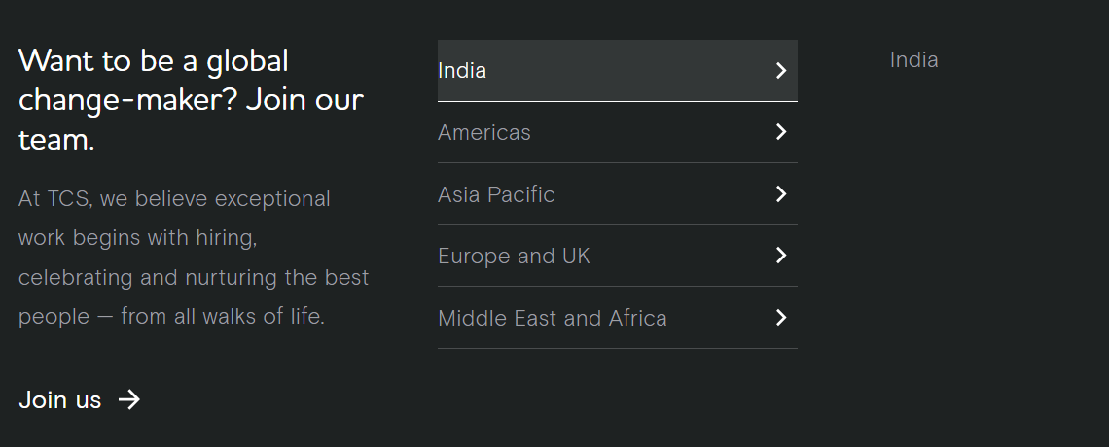

Join us->

JOIN US

Shape Tomorrow with Ikigai Automotive, Technology, Fashion, and More

As a global company with diverse business ventures and a growing international presence, Ikigai offers associates the opportunity to drive meaningful impact, support global partners, and contribute to long-term growth across multiple industries.

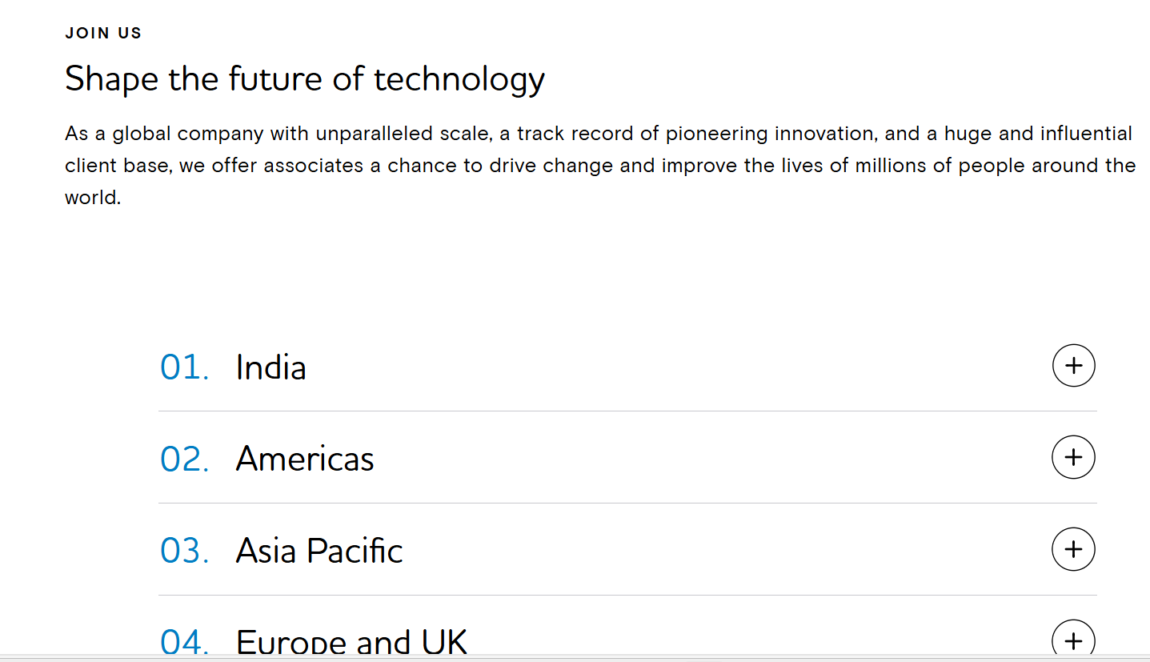

**HOME - PAGE**

**IKIGAI FUTURE GROUP VENTURES**

* **IKIGAI Technologies**

Innovative digital, automation, and smart mobility solutions.

* **IKIGAI Automotive Services**

End-to-end vehicle maintenance, diagnostics, and mobility support.

* **IKIGAI Constructions & Infrastructure**

Residential, commercial, and industrial construction with a focus on quality and sustainability.

* **IKIGAI Organics & Naturals**

Sustainably sourced organic and natural products for health and wellness.

* **IKIGAI Agro & Farm Stays**

Eco-friendly farming solutions and curated farm stay experiences.

* **IKIGAI Fashion**

Modern clothing and style essentials designed for confident living.

**About Ikigai Auto Parts**

A leading wholesale supplier of premium automotive spare parts based in Dubai, with over three years of experience and a strong reputation for quality, authenticity, and reliability in the global auto parts industry.

**Extensive Spare Parts Inventory**

Access to over 500K+ genuine original spare parts across all major vehicle brands, covering a comprehensive range from engine components to electrical systems, delivering complete and reliable automotive solutions.

**Worldwide Export Services**

Efficient logistics and shipping solutions serving over 85 countries worldwide, supported by fast order processing, competitive freight rates, and reliable delivery to ensure timely and consistent fulfilment.

**Wholesale & Bulk Solutions**

Competitive pricing tailored for dealerships, repair shops, and automotive businesses, with special rates for bulk orders, flexible payment terms, and dedicated account management for trade partners.

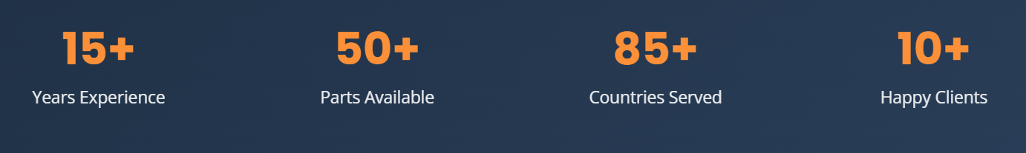

3+ Years Experience 500K+ Parts Available 85+ Countries Served 1K+ Happy Clients

14+ Years of Organization Experience

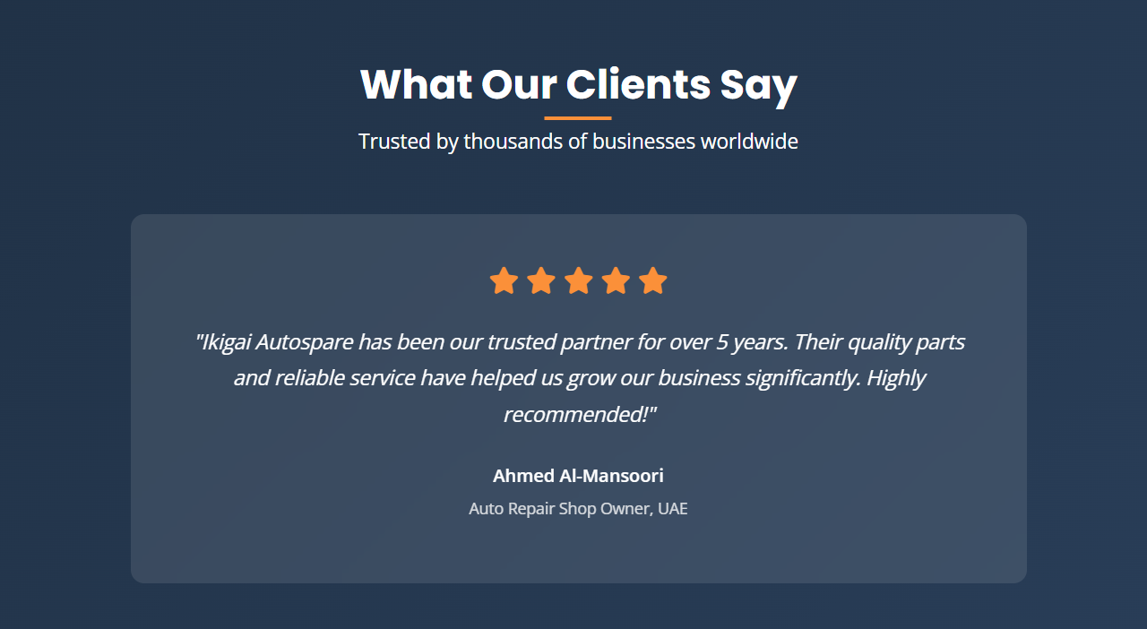

Change 5 years to 3 years

And add some more comments like auto changing. Comments from KSA, Libiya, Syria, Iran, Ethiopia, Tanzania, South Africa, Egypt

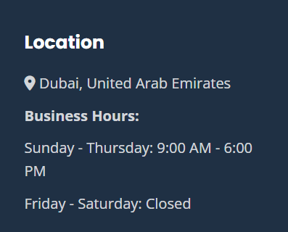

Meydan Grandstand, 6th Floor Meydan road, Nad Al Sheba, Dubai, United Arab Emirates

Business Hours : Monday – Friday 9:00 AM – 6:00 PM

Service Available: 24/7

Saturday – Sunday: Office Closed

**BRANDS - PAGE**

**Brands We Supply**

We supply genuine OEM original spare parts for all major vehicle brands. Our extensive inventory ensures accurate part availability for every application, backed by strict quality assurance and professional technical support across Japanese, European, American, Korean, and Chinese brands.

REMOVE ACURA

**Japanese Car brands**

Toyota, Lexus, Honda, Nissan, Infinity, Mitsubishi, Mazda, Isuzu, Subaru, Suzuki, Daihatsu, Hino

**European Car Brands**

Rolls-Royce, Jaguar, Land Rover, Bentley, Mini, Mercedes-Benz, BMW, Audi, Volkswagen, Porsche, Renault, Peugeot, Citroen, Fiat, Ferrari, Lamborghini, Iveco, Volvo, Skoda

**American Brands**

Ford, Chevrolet, GMC, Cadillac, Dodge, Jeep, Chrysler, Lincoln, RAM

**Korean Brands**

Hyundai, Kia, GM, Genesis

**Chinese Brands**

Geely, Jac, MG, Jetour

**Truck And Bus Parts**

MAN, Volvo, Mercedes Benz, Daewoo, TATA, Ashok Leyland, Renault, Scania, Iveco, DAF, Isuzu, Mitsubishi Fuso, Hino, Isuzu

**Construction Equipment Parts**

CAT, Komatsu, JCB, Kubota, Sany, John Deere, Ghallium, Bosch, TRW, MANN Filter, Denso, Donaldson, Valeo, ZF, Sachs

**Other Oils**

Shell, Total oil, Mobil, Castrol

**OEM & Aftermarket Options**

**OEM Parts – change to Genuine Original Parts**

**Aftermarket Parts – OK**

**Own brands**

Our own-brand product range includes high-durability, premium-quality parts for vehicle A/C gas systems, suspension, and brakes. Manufactured to strict standards, these parts are available in **Japan-made and China-made** variants, ensuring reliable performance and consistent quality across all applications.

**A Message From Our Founder**

At Ikigai Auto Parts, our journey began in 2024 with a clear purpose: to supply genuine, high-quality automotive spare parts to global markets with integrity, precision, and reliability. Founded in Meydan Free Zone, Dubai, UAE, the company was established to meet the growing international demand for trusted export partners in the automotive and construction sectors.

We specialize in genuine auto spare parts for commercial vehicles, non-commercial vehicles, and construction equipment. As a fully export-oriented business, we serve customers worldwide, ensuring that every product we deliver meets strict quality standards and manufacturer authenticity. Our strategic location in Dubai enables us to efficiently connect global suppliers with international customers through strong logistics networks and responsive supply chain management.

At Ikigai Auto Parts, we believe that success is built on long-term partnerships rather than short-term transactions. We focus on understanding our customers’ technical and commercial requirements and providing dependable solutions through accurate sourcing, competitive pricing, and timely delivery. Every shipment reflects our commitment to trust, transparency, and consistency.

We represent our dedication to purposeful work, continuous improvement, and creating sustainable value for our customers and partners across the globe. As we continue to grow, our focus remains unwavering: to become a globally trusted exporter of genuine automotive and construction spare parts.

Thank you for trusting Ikigai Auto Parts. We look forward to building lasting success together.

**Our Story**

Ikigai Auto Parts was founded in Meydan Free Zone, Dubai, 3 years ago, with a strong purpose: to serve global automotive and construction parts markets with genuine products and reliable service. Our business is built on deep industry experience and a clear understanding of what customers truly need.

The idea of Ikigai Auto Parts was born from our experience working in different organizations, where we noticed a major gap: customer needs were often overlooked, and support was limited to working hours. We decided to build a company that would change this — a partner that is available **100% of the time**, ready to respond and support our customers whenever they need us.

As the founder, I bring **14 years of technical and data management expertise**, while our co-founder contributes **14 years of experience in auto parts**. Together, we combine industry knowledge with strong systems and data-driven processes to support parts sourcing teams worldwide. This enables us to deliver high-quality products with full transparency and dependable delivery.

Our commitment to partners goes beyond product supply. We prioritize **data security**, accurate documentation, and **24/7 immediate response** to ensure smooth operations and uninterrupted support. We believe that timely communication and reliability are essential for global trade.

**Our Mission**

Our mission is to drive excellence across all Ikigai ventures by delivering authentic, high-quality solutions, strengthened by exceptional service, competitive pricing, dependable operations, and sustainable long-term global partnerships.

**Our Vision**

To build a world-class portfolio of Ikigai ventures that set international benchmarks in quality, reliability, and long-term partnership excellence.

**Our Values**

**1. Integrity, Data Security, Partner Confidentiality & Trust**  
The highest standards of data protection and confidentiality are upheld, ensuring that customer and partner information is handled with complete security and trust. The confidentiality of global partners is respected and safeguarded, fostering long-term relationships built on transparency, reliability, and mutual respect.

**2. Authenticity & Service Excellence**  
We are committed to delivering authentic products and best-in-class service, consistently exceeding expectations across all Ikigai ventures.

**3. Global Reach & Supply Commitment**  
We ensure seamless global availability of products from all Ikigai ventures, supported by efficient supply chains and reliable operational execution worldwide.

**4. Customer-Centric Problem Resolution**  
We proactively address customer concerns with accountability and professionalism, treating every challenge as an opportunity for productive and value-driven solutions.

**5. Unity**

Ikigai invests in its people and partners, fostering continuous learning and building caring, collaborative relationships based on trust and mutual respect. These values guide Ikigai in its mission to deliver excellence and create value for customers and communities, shaping the company’s culture and inspiring its workforce to achieve shared goals.

Change 50000+ to 500K parts

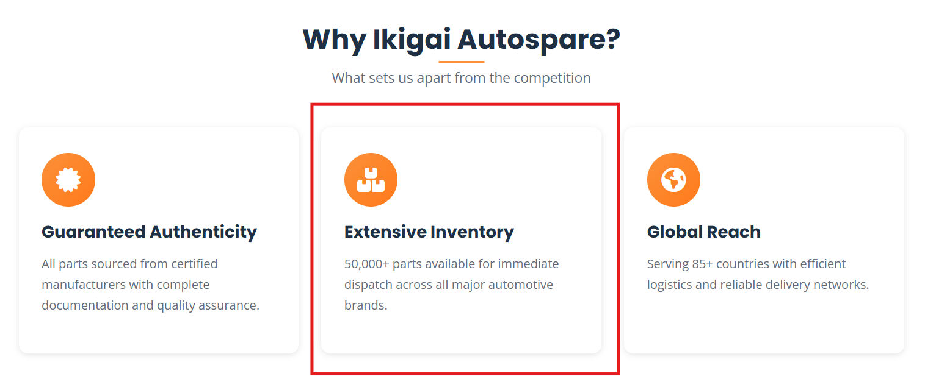

Remove ISO certified and add some other point

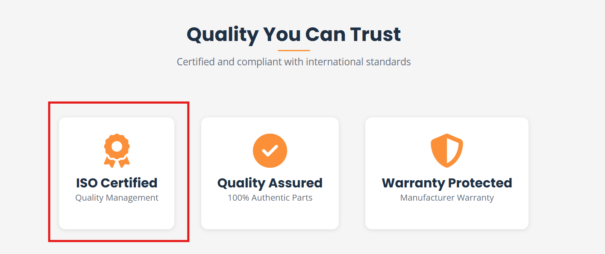

**BLOGS**

**1. Driving Quality, Delivering Globally**

**Blog Content:**  
Ikigai Auto Parts is a Dubai-based re-export company operating from Meydan Free Zone. We specialize in supplying genuine and aftermarket automotive spare parts to global markets, ensuring quality, reliability, and competitive pricing.

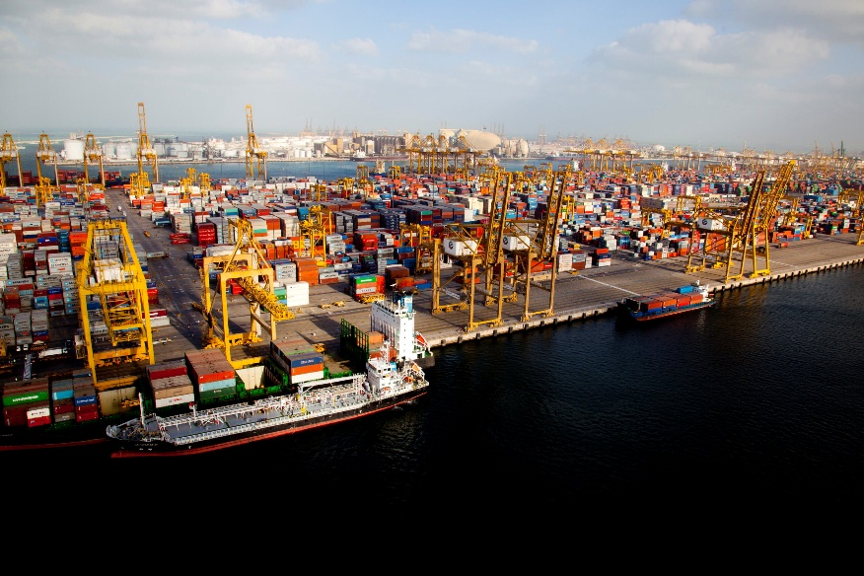

**2. Why Dubai Is the Global Hub for Auto Parts Re-Export**

**Blog Content:**  
Dubai’s strategic location, advanced logistics, and free zones make it the ideal hub for automotive spare parts re-exports. Ikigai Auto Parts leverages these advantages to serve customers across GCC, Asia, Europe, and Africa efficiently.



**3. Benefits of Buying Auto Parts from a Free Zone Company**

**Blog Content:**  
Operating from Meydan Free Zone allows Ikigai Auto Parts to offer tax-efficient pricing, faster documentation, and smooth re-export processes—helping customers reduce overall procurement costs.

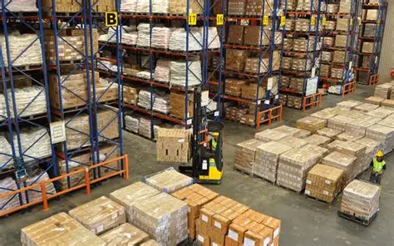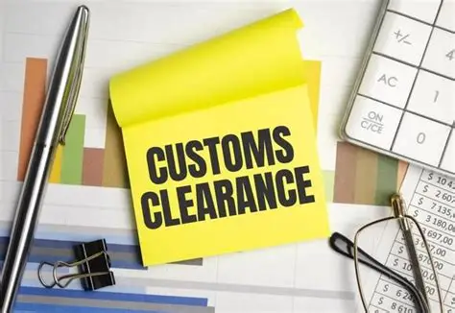

**4. Genuine vs Aftermarket Auto Parts: What Should You Choose?**

**Blog Content:**  
Understanding the difference between genuine and aftermarket parts is crucial. Ikigai Auto Parts supplies both options, helping customers select the right balance of quality, warranty, and cost.

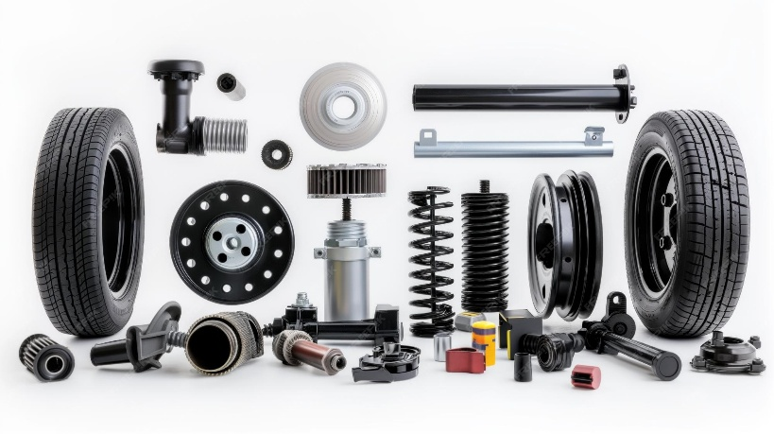

**5. Japanese Auto Spare Parts We Supply Worldwide**

**Blog Content:**  
We specialize in Japanese brands such as Toyota, Nissan, Mitsubishi, Isuzu, and more—serving passenger vehicles and commercial fleets across international markets.

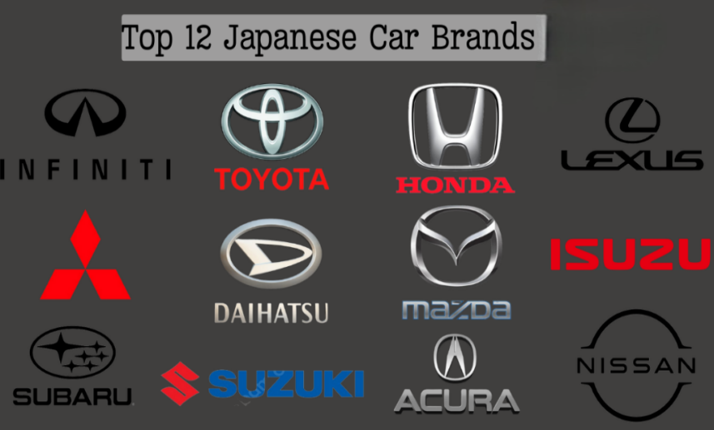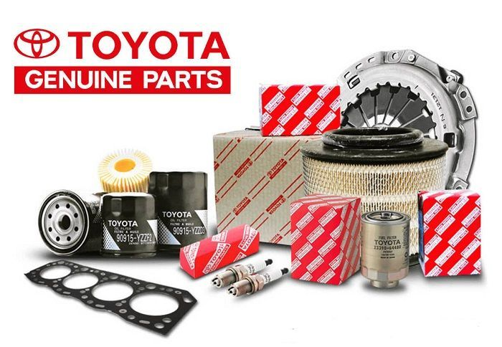

**6. Korean, American & European Auto Parts Under One Roof**

**Blog Content:**  
Ikigai Auto Parts supplies Korean, American, and European automotive parts, offering a one-stop solution for global buyers looking for diverse brands and models.

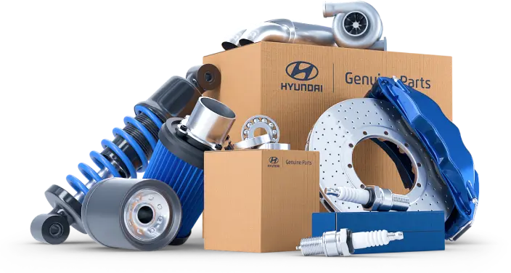

**7. Commercial Vehicle Spare Parts for Heavy-Duty Performance**

**Blog Content:**  
We support trucks, buses, and heavy vehicles with durable spare parts designed for long-distance and high-load performance, meeting international quality standards.

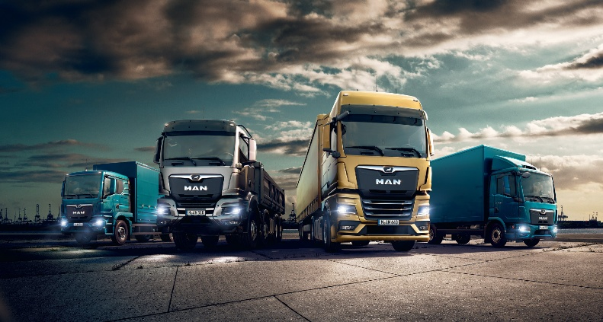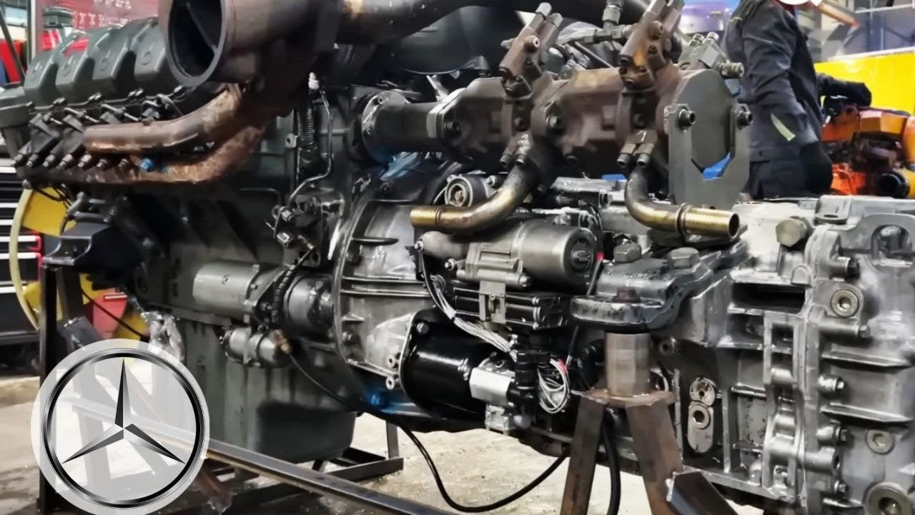

**8. Our Global Export Network**

**Blog Content:**  
Ikigai Auto Parts exports to UAE, Kuwait, Oman, India, Singapore, Russia, Malaysia, Iran, Libya, Syria, and more—building long-term partnerships worldwide.



**9. How We Ensure Quality in Every Shipment**

**Blog Content:**  
From supplier verification to packaging and inspection, quality control is at the core of Ikigai Auto Parts’ operations—ensuring customers receive dependable products every time.

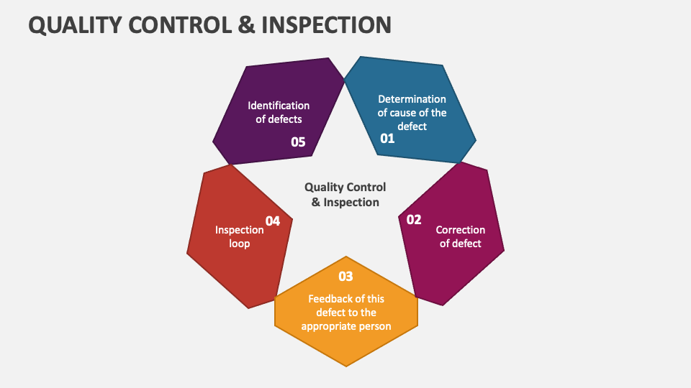

**10. Fast & Reliable Logistics for International Buyers**

**Blog Content:**  
Our logistics expertise enables fast dispatch, accurate documentation, and secure packaging—minimizing delays and ensuring timely deliveries worldwide.

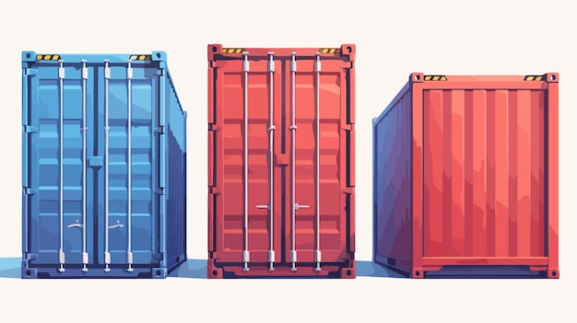

**11. Re-Export Solutions for GCC Countries**

**Blog Content:**  
We provide seamless re-export solutions for GCC clients, ensuring compliance, efficient customs handling, and competitive pricing without unnecessary delays.

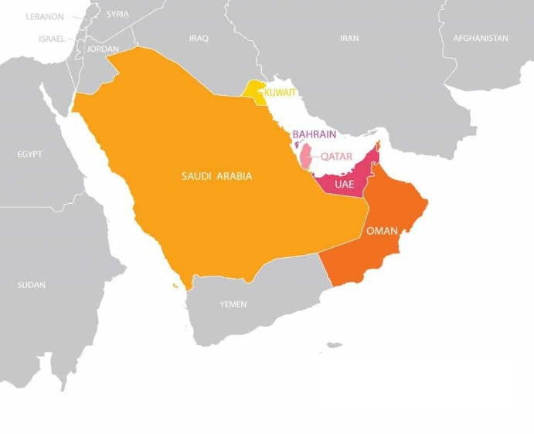

**12. How Ikigai Auto Parts Supports Bulk Buyers & Wholesalers**

**Blog Content:**  
We cater to wholesalers, distributors, and fleet operators with bulk pricing, consolidated shipments, and flexible sourcing options.



**13. Choosing the Right Auto Parts Supplier in Dubai**

**Blog Content:**  
Selecting a reliable supplier is critical. Ikigai Auto Parts stands out through transparency, product range, export expertise, and customer-focused service.



**14. The Future of Automotive Spare Parts Trade**

**Blog Content:**  
Digital sourcing, global demand, and efficient logistics are shaping the future of the auto parts industry. Ikigai Auto Parts continues to evolve to meet modern market needs.



**15. Why Customers Trust Ikigai Auto Parts**

**Blog Content:**  
Trust is built through consistency, quality, and service. Ikigai Auto Parts is committed to long-term relationships and dependable supply chains.



**16.** **We are pleased to announce that Ikigai Auto Parts has entered into a strategic partnership with Asian distributors for the supply of Japanese automotive spare parts.**

This collaboration strengthens our sourcing network and enables us to offer a wider range of high-quality, reliable components at competitive prices to our global customers. With this partnership, we further reinforce our commitment to delivering trusted Japanese auto parts with efficiency, consistency, and international reach.



**Ikigai Auto Parts**  
Driving Quality. Delivering Globally.

**17. Happy to Announce: Serving 1,000+ Valued Customers Worldwide**

We are proud to announce a major milestone in the journey of Ikigai Auto Parts — successfully reaching 1,000+ customers across global markets.

What started as a focused vision to deliver quality automotive spare parts has grown into a trusted international supply network. From our base in **Meydan Free Zone, Dubai**, we now support customers across the **GCC, Asia, Europe, and emerging markets**, supplying reliable solutions for both commercial and non-commercial vehicles.

This achievement reflects the **trust and confidence** our customers place in us. Every order, inquiry, and long-term partnership has played a vital role in helping us reach this landmark.

**Our Commitment to Quality and Reliability**

At Ikigai Auto Parts, we believe growth is meaningful only when driven by consistency and value. Our success is built on:

* Supplying **genuine and high-quality aftermarket spare parts**
* Strong partnerships with **global and Asian distributors**
* Efficient **re-export and logistics solutions**
* Transparent communication and customer-focused service

**Looking Ahead**

Reaching 1,000 customers is not just a number—it’s a responsibility. As we continue to expand our product range and global reach, our commitment remains unchanged:  
**Driving Quality. Delivering Globally.**

We sincerely thank our customers, partners, and team members for being part of this journey. We look forward to serving many more customers and building long-lasting partnerships worldwide.



**18. Requirements for Building Strong Business Relationships**

In today’s competitive global market, strong business relationships are the foundation of long-term success. At **Ikigai Auto Parts**, we believe that trust, consistency, and mutual growth are the cornerstones of every successful partnership. Building and maintaining strong relationships with customers, suppliers, and logistics partners requires intention, effort, and the right values.

**1. Trust and Transparency**

Trust is the most critical requirement in any business relationship. Clear communication, honest pricing, and transparent processes help build confidence and credibility over time. When partners know they can rely on accurate information, relationships naturally grow stronger.

**2. Consistent Quality and Reliability**

Consistency creates confidence. Delivering the right product, in the right condition, and on time—every time—demonstrates reliability. In the automotive spare parts industry, consistency in quality and supply is essential for long-term cooperation.

**3. Effective Communication**

Open and timely communication helps prevent misunderstandings and strengthens collaboration. Regular updates, prompt responses, and clear documentation ensure that expectations are aligned on both sides.

**4. Understanding Customer Needs**

Strong relationships are built by listening. Understanding the specific requirements of customers and partners allows businesses to offer tailored solutions rather than one-size-fits-all services. This approach leads to higher satisfaction and loyalty.

**5. Commitment to Long-Term Partnership**

Successful relationships are not built overnight. A long-term mindset—focused on growth, continuity, and mutual benefit—helps create partnerships that withstand market changes and challenges.

**6. Professionalism and Integrity**

Professional conduct and ethical business practices form the backbone of lasting relationships. Respect, accountability, and integrity foster a positive working environment and encourage repeat business.

**7. Adaptability and Support**

Markets evolve, and so do business needs. Being flexible and supportive during changing circumstances strengthens trust and shows commitment beyond transactions.

**Conclusion**

Building strong business relationships requires more than just successful transactions—it requires trust, consistency, communication, and a shared vision for growth. At **Ikigai Auto Parts**, we are committed to nurturing long-term relationships that create value for all stakeholders.

**Driving Quality. Delivering Globally.**

